## Impact FTP Batch Server Guide

### 1. Overview

The **Impact FTP Batch Server** is an **Express.js** application designed to upload CSV files to **Impact.com** efficiently.

### 2. Installation & Setup

After extracting the ZIP file, follow these steps to install and run the server:

npm install

npm run dev

Once executed, the server will be up and running.

### 3. Configuring the Shopify Integration

In the root directory, you will find client.script.js. This script is intended for injection into the **Shopify** application.

The script has already been added to the **Shopify account**. The only configuration required is to set the **Impact FTP Batch Server API URL** that you have deployed.

Update the URL as follows: <https://YOUR_SERVER_DOMAIN/api/track/wine-club-signup>  
  
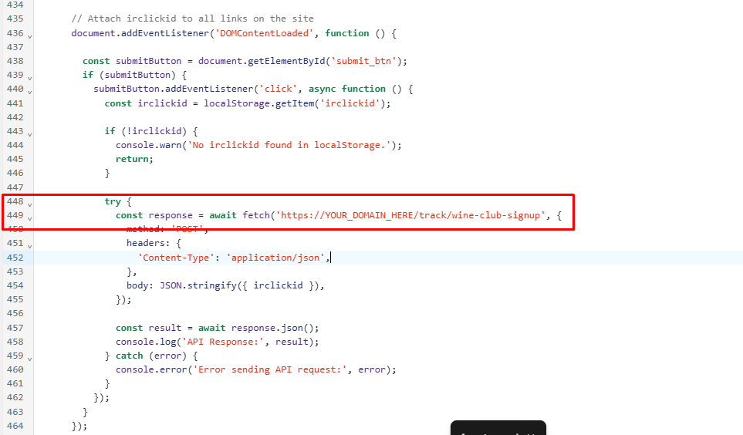

To configure this in Shopify:

1. Navigate to **Shopify Admin** → **Online store**→ **Themes -> them.liquid**.
2. Update the **active URL** with your deployed server's API endpoint.

### 4. Testing & Verification

Once everything is properly configured:

1. Visit [**McBride Sisters Website**](https://www.mcbridesisters.com/).
2. Proceed with the **signup process**.
3. Upon clicking the **"Create Password"** button, the system will automatically generate and upload a **CSV file** to **Impact.com**, registering the corresponding action.

That’s it! Your integration is now successfully set up. 🚀